**Problem of the Week # 8**

**Ocean Legs**

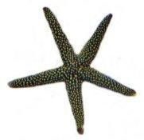 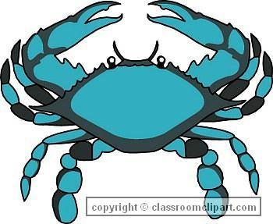 

As I was scuba diving, I looked down on the ocean floor and saw crabs and starfish. I counted 30 legs.

**How many crabs and starfish could I have seen?**

**Show all combinations using pictures, numbers or symbols.**

*Hint: a crab is a member of the order, Decapod, which means 10-footed, so it has 10 legs.*